KAMARAJ COLLEGE, THOOTHUKUDI

DEPARTMENT OF PHYSICS

GROUP MEMBERS :

R.NIVETHA

T.MUTHU PRABAHAR

M.SUDALAI MANIKANDAN

M.NATHIYA

PROJECT REPORT

Political Juggernauts: A Quantitative Analysis Of

Candidates In The 2019 Lok Sabha Elections

1. Introduction:
   1. Overview:

The Lok Sabha is composed of representatives of people chosen by direct election on the basis of Universal Adult Suffrage. The Constitution of India allows for a maximum of 550 members in the House, with 530 members representing the States and 20 representing the Union Territories. The 17th Lok Sabha was formed by the members elected in the 2019 Indian general election. Elections, all across India, were conducted in seven phases from 11 April 2019 to 19 May 2019 by the Election Commission of India.

* 1. Purpose:

The Election Commission of India recognises parties as either national or state parties based on their performance in previous elections. Delhi and Haryana have a high number of candidates contesting from parties that have not been recognised as either national or state parties.After Telangana, Tamil Nadu has the highest average of independent candidates contesting in this election. On average, of the candidates in each constituency in Tamil Nadu, two-thirds are contesting as independent candidates.

1. Problem Definition & Design Thinking:

On average, no-confidence motions (excluding the one being discussed today) have been discussed for 13 hours over three days. Discussions have lasted longer than 20 hours on four instances, most recently in 2003. Today’s no-confidence motion was allotted 12 hours discussion time by the Business Advisory Committee. Following the discussion, the motion is put to vote. 26 out of 27 no-confidence motions (excluding the one being discussed today) have been voted upon and rejected. This means that no government has ever had to resign following a vote of no-confidence. On one occasion, in 1979, the discussion on a no-confidence motion against the Morarji Desai government remained inconclusive.

* 1. Empathy Map:

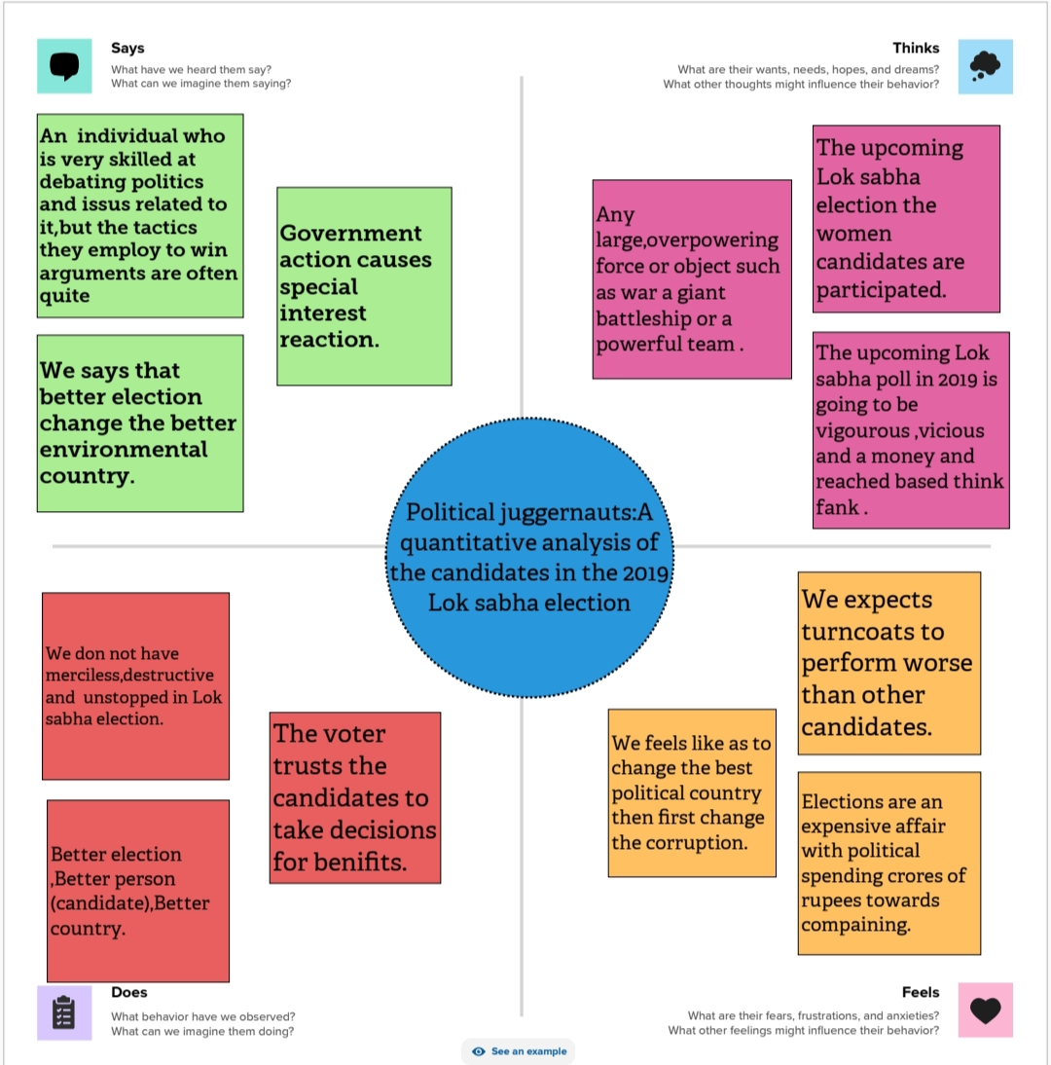

* 1. Brainstorm Map:

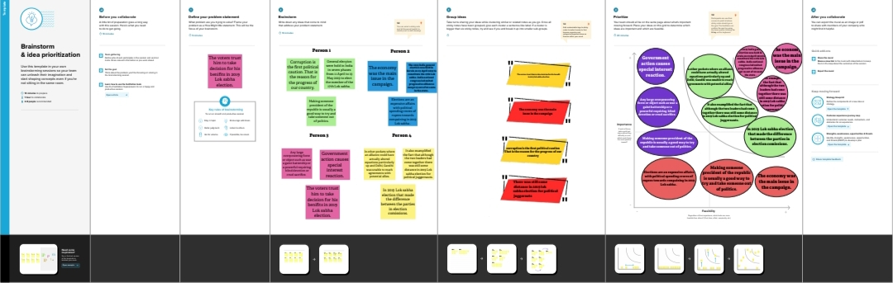

1. Result:

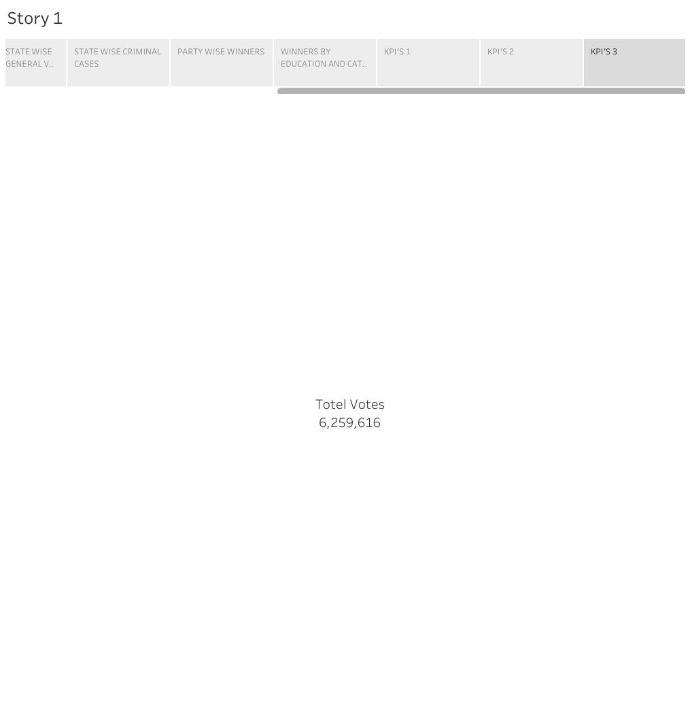

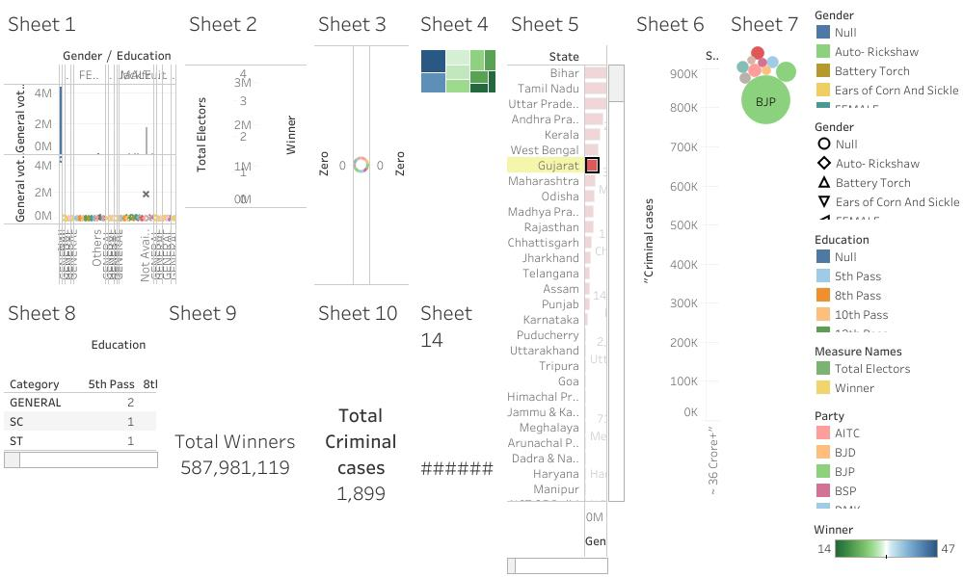

1. Advantages & Disadvantages:

The biggest disadvantage is probably that citizens aren’t very good at voting for the right people. Democracy is like a company with a really, really terrible hiring manager. The advantage is that it’s better than any other way of picking leaders.

1. Applications:

The 2019 Indian general election saw the widespread and innovative use of digital media and technology. Most political parties employed digital media extensively for campaigning and voter mobilisation. This extensive use of digital media was due to nearly half of India’s 900 million eligible voters having access to the Internet and social media. The country has 300 million Facebook users and over 200 million on WhatsApp, which is more than any other country.

1. Conclusion :

Scheduling refers to arranging and controlling of Elections. Elected officials are accountable to the people. Therefore, they must return to the voters at regular intervals of time. Elected officials must do that so as to seek a mandate to continue in office. Above all, most countries arrange elections at fixed regular interval An election campaign is also an integral part of Election. Election campaign refers to an organized effort to positively influence the decision making of a particular group. Consequently, politicians compete with each other by trying to woo more and more individuals.

1. Future Scope:

The challenge of developing electronic voting systems is not only security but also protecting the secrecy of the ballot, a bedrock principle of free and fair elections. Currently there is “no known technology that can guarantee the secrecy, security, and verifiability of a marked ballot transmitted over the Internet.” 1 Online voting presents numerous vulnerabilities and is fundamentally insecure. There is potential for unobserved vote manipulation as well additional security vulnerabilities including potential denial of service attacks, malware intrusions, and privacy concerns. Online voting does not produce a paper trail for auditing.

1. Appendix :

* Alliance of the North
* Animal Protection Party of Canada
* Bloc Québécois
* Christian Heritage Party of Canada
* Communist Party of Canada
* Conservative Party of Canada
* Green Party of Canada
* Liberal Party of Canada
* Libertarian Party of Canada
* Marijuana Party
* Marxist-Leninist Party of Canada
* National Citizens Alliance of Canada
* New Democratic Party
* People’s Party of Canada
* Progressive Canadian Party
* Rhinoceros Party